In my academic career I have dealt a lot with working in groups and from that experience comes a lot of knowledge. Knowledge that I have learned but also personal insight of what my strengths and weaknesses are. From all the group projects I have done, I can say I’m always the one who is personally connected to everyone and often keeps the group together. No matter what someone is like, I can always get along. I think that it is important in a group that there is at least one person that you like. Because I have personally noticed in groups that I am the one that people come to when they have personal issues with someone else. Also I can take charge when it is necessary to do so. When things turn into a mess, I always take the leading role and try under the pressure to make it right.

My weak points is executing my planning. It’s always a precise job to follow things as planned. Looking at the clock and immediately starting executing a task that was planned is always a hard thing in reality. Also I find it hard to get up on my own. When I lose sight of what is in front of me, I tend to get overly worried and always need support of others to get over this. If I feel stuck in a task, I need help and consultation of others to oversee this, otherwise I feel like I will be there forever.

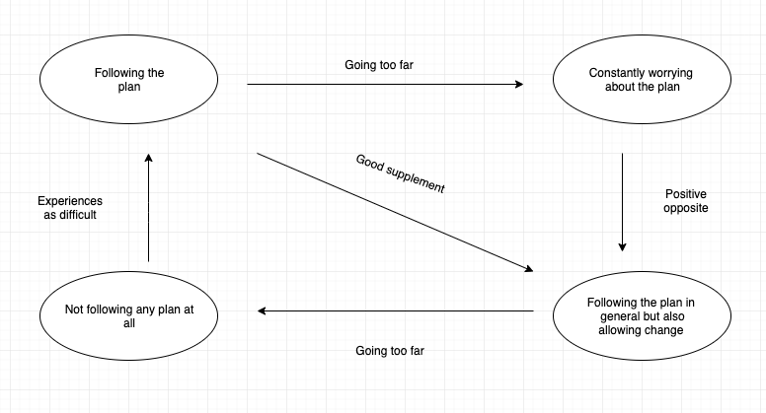

**G**

I have little prior knowledge about coding in java, so that is very important for me to work on, because java is an important main language for programmers and I feel like it is important to know this one very well, because it will help me understanding other languages that I’m also interested in. I think I will feel successful achieving this when I’m doing above average than my peers.

In every group project I have done in the past, there is always something I picked up about social interaction with others in a professional environment. I hope to learn more about behaving like a professional, because this is an important personality trait when looking for a job.

**R**

I am definitely working on the first goal, since this is also currently the only possible one. I’m doing loads of self studying by checking out websites and videos than can help me. What goes well is me understanding lots by myself, but I can never decide whether I should ask for help or actually or try to solve it on my own.

**O**

My options to achieve goal is mainly practicing and trying interact socially as much as possible. I think practicing would be my favourite option, since this is an option that I can do anytime and anywhere. And the only stopping me, is me. I have to get up and do the work, nothing else.

**W**

I will do as much self studying as possible to reach my goals. And this is something I have already started the first weekend, which is a firsts step I have taken. My teammates can help me by giving me constructive criticism and also telling about what they like and don’t in a working environment. So concrete plans would be practice and interact with my teammates as much as possible.